Question 3 Test 2 (P166246 – Muzaffar Izamuddin bin Daud)
3a) First we plot the audio using timer function. The timer function requires a little bit of smoothing in order to clearly distinguish between the 2 chirps.
First we load the data:
z <- readWave("C:/Users/PC03/Desktop/Unstructured - Muz/Test_2/audio.wav")
play(z)
Here is a plot of using a high smoothing parameter, able to clearly distinguish 2 separate chirps.
timer(z, f=22050, threshold=25, msmooth=c(1500,0))
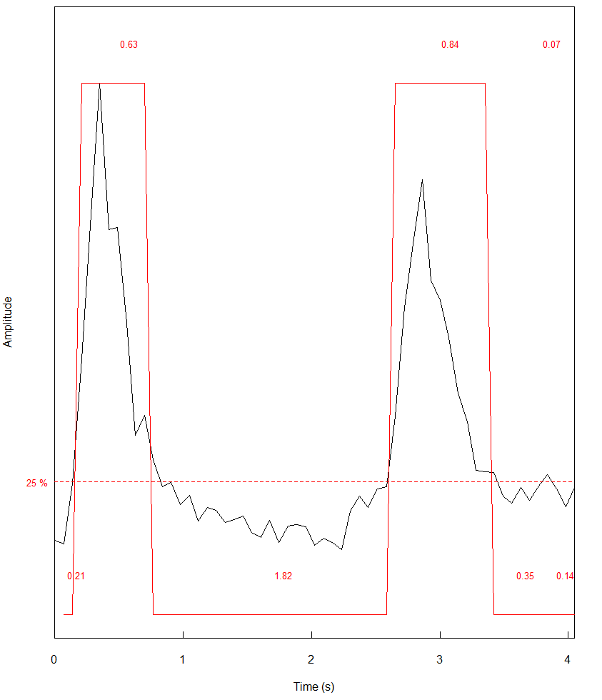
Plot 1 : timer plot using smoothing of 1500 and threshold of 20%

A lower smoothing parameter was also used as below to show:
timer(z, f=22050, threshold=30, msmooth=c(500,0))

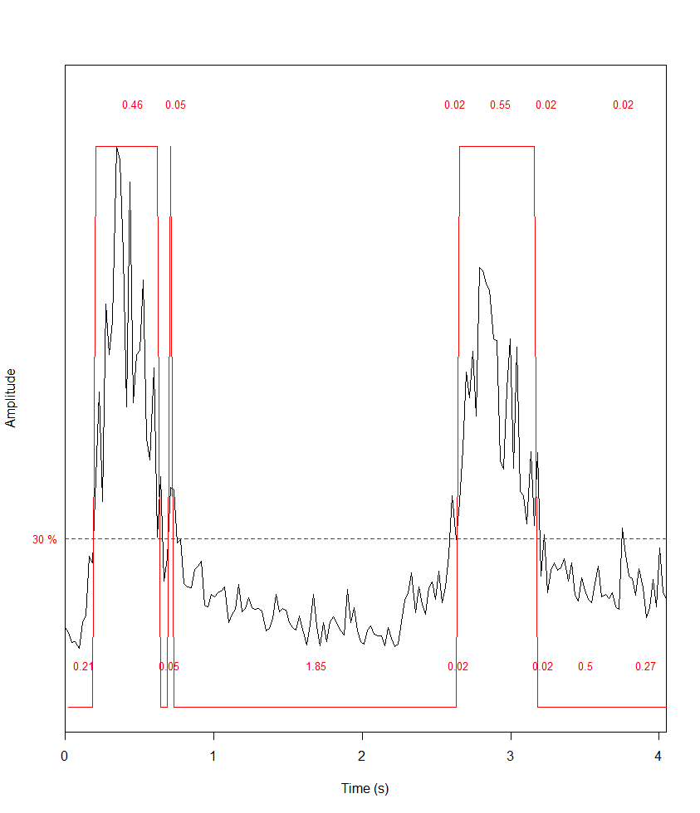
Plot 2 : timer plot using smoothing of 500 and threshold of 30%

Explanation:
What can be seen from the plot is that there are a total of 2 chirps. The first chirp is shorter than the second chirp lasting about 0.63s while the second chirp lasted for 0.84s. A lower smoothing parameter capture a few more smaller peaks, however the main two peaks can be heard and distinguish by the human ear.
3b) Spectrogram plot
install.packages('rpanel')
library(rpanel)
windows(10,10)
spectro(z)

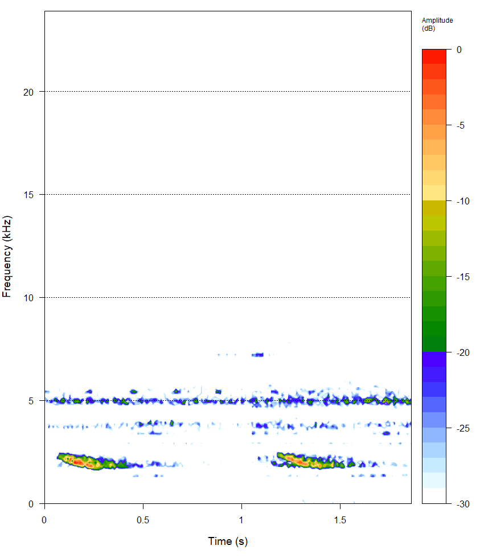
Explanation: Next we plot the spectrogram plot using the spectro function in R. This plots is able to summarize all three important parameters including frequency, amplitude as well as time in one 2d plot. We can clearly see the 2 chirps when looking for 2 concentrations of red amplitude. The frequency of the loud chirps are lower at around 2.4kHz. There is also an almost constant sound at 5kHz. This can represent the bird song’s base frequency before it starts a louder and lower frequency chirp. A fainter ~4kHz line is also seen on the spectrogram and this could be due to harmonics from the first 5kHz baseline or the bird itself capable of vibrating at a different frequency. The plot confirm our timer plot of 2 main high amplitude chirps.
3c,d and e) left FFT and frequency spectrum plot and explanation
plot.frequency.spectrum <- function(X.k, xlimits=c(0,length(X.k))) {
plot.data <- cbind(0:(length(X.k)-1), Mod(X.k))
plot.data[2:length(X.k),2] <- 2*plot.data[2:length(X.k),2] # scale (all except DC bin)
plot(plot.data, t="h", lwd=2, main="",
xlab="Frequency (Hz)", ylab="Strength",
xlim=xlimits, ylim=c(0,max(Mod(plot.data[,2]))))
}
Zk <- fft(z@left)
plot.frequency.spectrum(Zk)
plot.frequency.spectrum(Zk[1:40000])
title("Frequency Spectrum Plot of audio.wav")

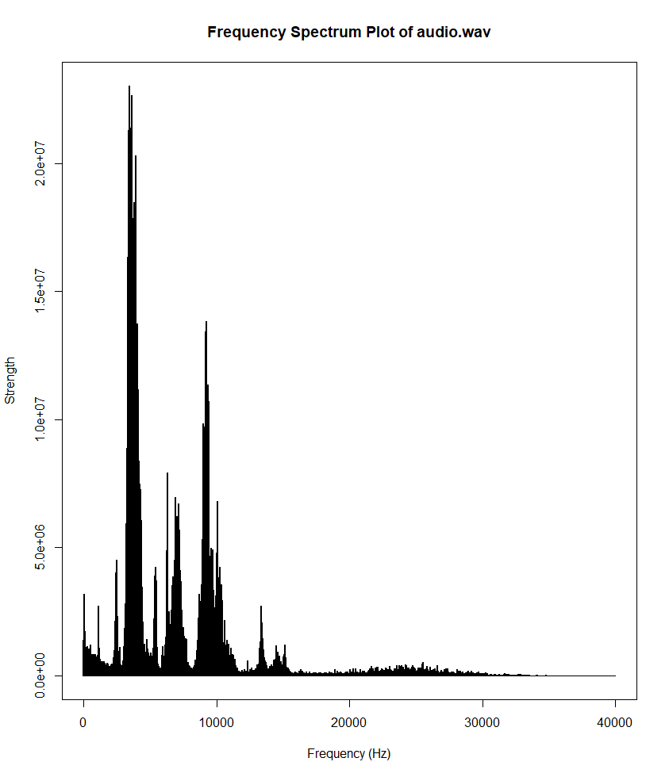

Explanation (3e)
For this plot we first define a function called plot.frequency.spectrum to help use plot the frequency spectrum. The command z@left was used in order to construct the left channel audio signal using fft function as per the question in 3c.

Then we use the command plot.frequency.spectrum to call the function that was defined earlier in order to plot the frequency spectrum. Please note this is the frequency spectrum for the whole audio file as the question did not ask for a short time plot. What we can see there are 2 main peaks – 1 occurred at 10kHz while the other occurred at <5kHz. The most frequently occuring frequency (or highest strength) occurred at 4-5kHz matching up with the plot we saw when we used spectro where there is an almost constant noise at 5kHz region. At 10kHz there is also a peak in strength, although this is not seen in spectrogram plot perhaps due to the low amplitude at this frequency.

We can use the dynspec function to investigate and explain the plot further:
layout(t(1:1))
windows(10,10)
dynspec(z, wl=1024, osc=T) #supporting for question 3e

Using the dynspec function we cut the signal at 2 time period, 1 t 0.181s and another at 1.291s. The first plot corresponds to the first chirp while the second refers to the second chirp. We can see that the amplitude in both chirps is reaching up to 0.6 at around 2-2.5kHz with a second smaller amplitude at the frequency of 5kHz reaching only a level of amplitude of about 0.1. Both chirps mirror each other in terms of both frequency and noise.

By using both the frequency spectrum plot, spectrogram and the dynspec plot we are able to clearly understand the audio signal from all important angles including frequency, amplitude and time domain.
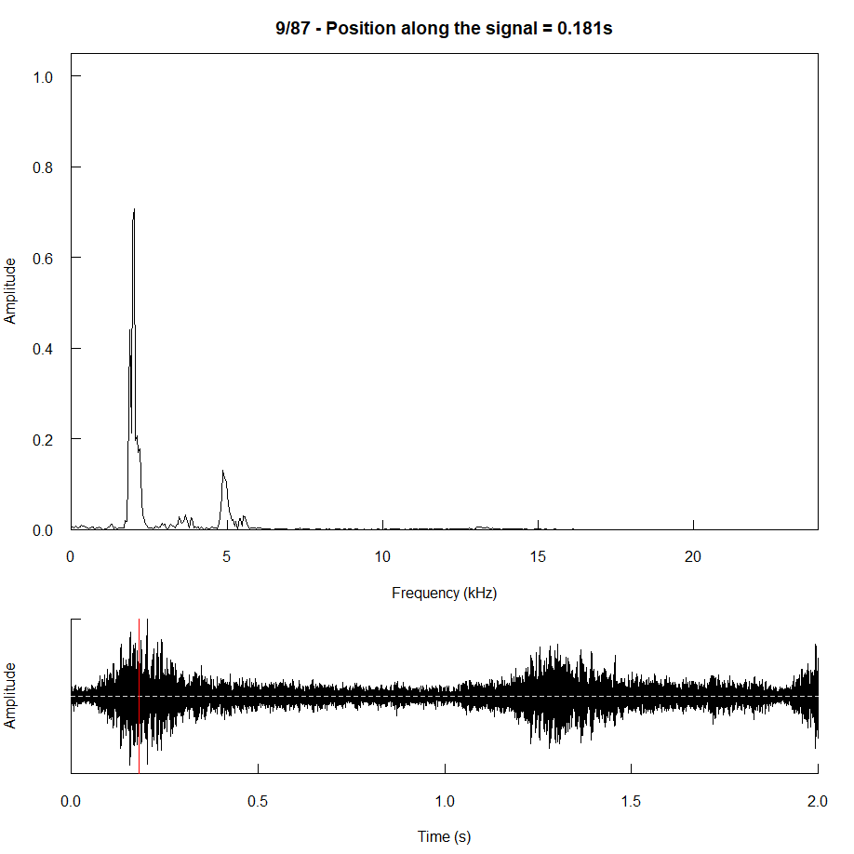
Plot: Dynspec of first chirp

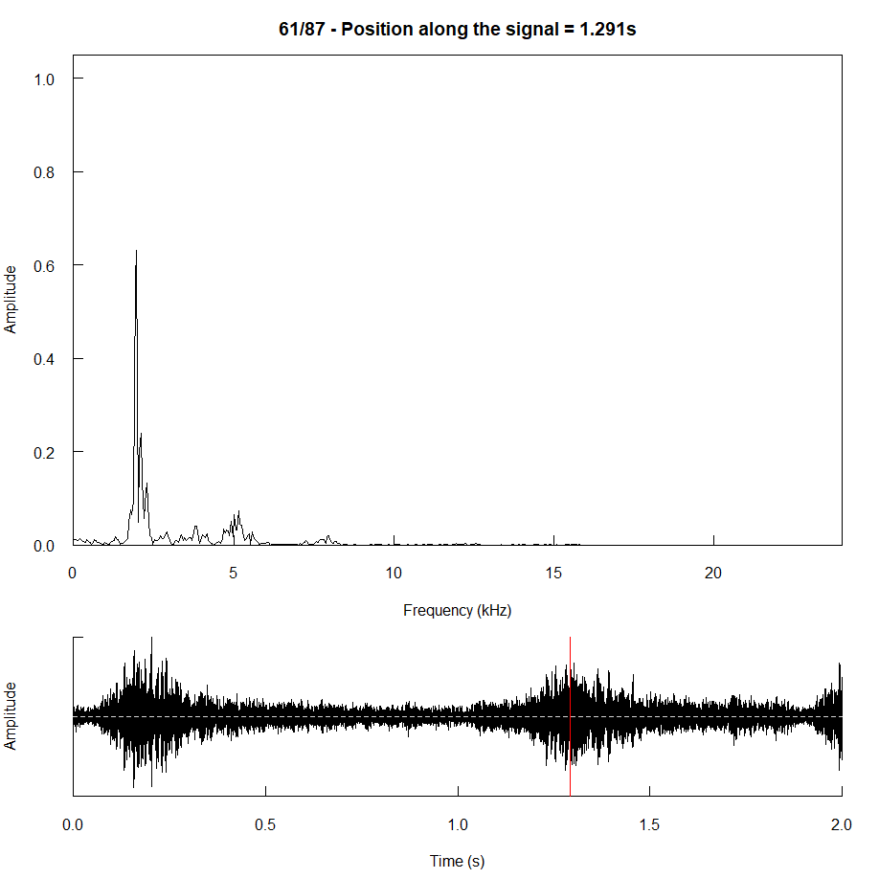
Plot: Dynspec of second chirp

R code:
#Name: Muzaffar Izamuddin bin Daud
#Matrix number: P166246
# Question 3 R code

install.packages('tuneR')
install.packages('seewave')
library(tuneR)
library(seewave)

plot.frequency.spectrum <- function(X.k, xlimits=c(0,length(X.k))) {
plot.data <- cbind(0:(length(X.k)-1), Mod(X.k))
plot.data[2:length(X.k),2] <- 2*plot.data[2:length(X.k),2] # scale (all except DC bin)
plot(plot.data, t="h", lwd=2, main="",
xlab="Frequency (Hz)", ylab="Strength",
xlim=xlimits, ylim=c(0,max(Mod(plot.data[,2]))))
}

z <- readWave("C:/Users/PC03/Desktop/Unstructured - Muz/Test_2/audio.wav")
play(z)

timer(z, f=22050, threshold=25, msmooth=c(1500,0)) #question 3a

install.packages('rpanel')
library(rpanel)
spectro(z) #question 3b

Zk <- fft(z@left) #question 3c
plot.frequency.spectrum(Zk)
plot.frequency.spectrum(Zk[1:40000]) #question 3d
title("Frequency Spectrum Plot of audio.wav")

layout(t(1:1))
windows(10,10)
dynspec(z, wl=1024, osc=T) #supporting for question 3e
meanspec(z) #not used in this test, but plots an average of the frequency spectrum

